A2(Team) MVP Final Version

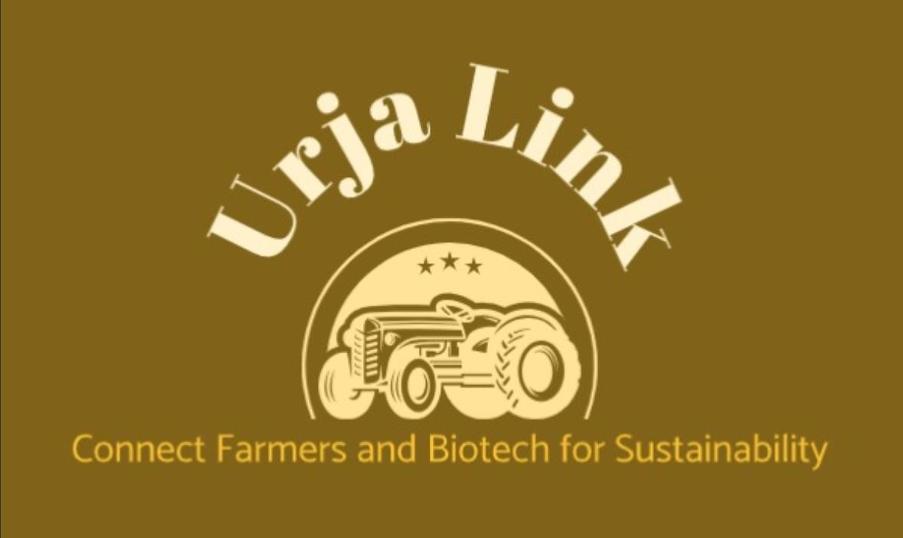

### Arunima Bollampally

# MVP Development & Analysis

Farmers face challenges in managing crop stubble, often resorting to burning crop residues, which contributes to air pollution, soil degradation, health risks for nearby communities, and economic losses. At the same time, biofuel companies face challenges in sourcing a consistent, high-quality supply of biomass for fuel production. The lack of an efficient collection and distribution system results in wasted agricultural residues that could otherwise be used for renewable energy.

Our AI-powered logistics company is designed for farmers who want to sell their produce without the hassle of transporting their stubble. We, URJA LINK, are providing the logistics to transfer stubble to biofuel companies, creating a reliable and scalable supply chain for stubble-based biomass.

Features of our **URJALINK** website:

https://preview--farmwaste-marketplace.lovable.app/auth

✔ Separate modules for Seller (farmers) and buyers (biofuel companies)

✔ Seller module has information on the

* Type of the Stubble, photo
* Location of pick up
* Distance
* Quantity, price
* Status of Acceptance or rejection

✔ Buyer module has the information on the

* Type of the Stubble
* Price per Grade
* Location of pick up
* Distance
* Estimated receipt time
* Amount of Co2 reduced

# PROCESS FLOW CHARTS:

Through marketing, we will make our toll-free numbers available to farmers. They can call and talk to our AI assistant or service agent and register their product. Our role starts with receiving an order from the farmers and locating the nearest biofuel buyer from the website information. We will then check for the nearest available truck to collect the stubble. Once the stubble reaches the buyers, the biofuel company tests the material in their lab and generates a report within 24 hrs. Based on the grade assigned to the stubble in the report, we convey the price to the farmer and lock the deal. We give a buffer period of 1-2 days for the buyer to make the payment. After receiving the payment, we will credit the money to the farmer's account.

## Model Structure:

URJA LINK follows an AI-powered, three-layered model integrating farmers, logistics, and biofuel companies:

### Data Collection & Farmer Registration

* + Farmers can register their stubble through an AI-powered voice assistance system, a dedicated website, or service agents. This multi-channel approach ensures accessibility, particularly for the 87% of farmers who own mobile phones, including those with limited internet proficiency.
  + Input includes stubble type, location, quantity, and price expectations.
  + AI-assistant guides farmers in regional languages helping them in hassle free information.

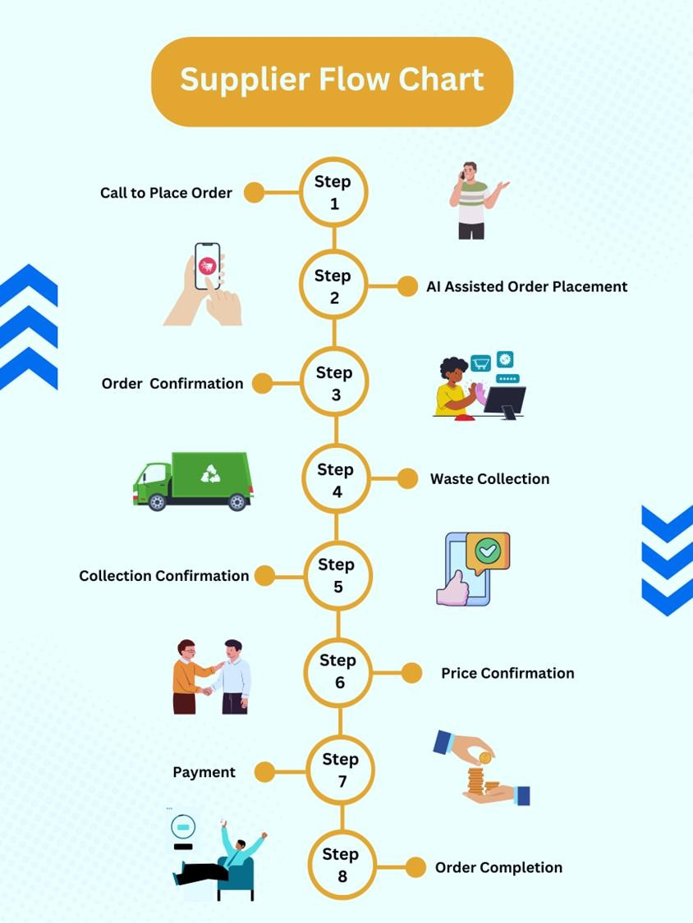

### Logistics Optimization

* + AI helps us match farmers’ orders with nearby biofuel buyers based on stubble type and demand.
  + 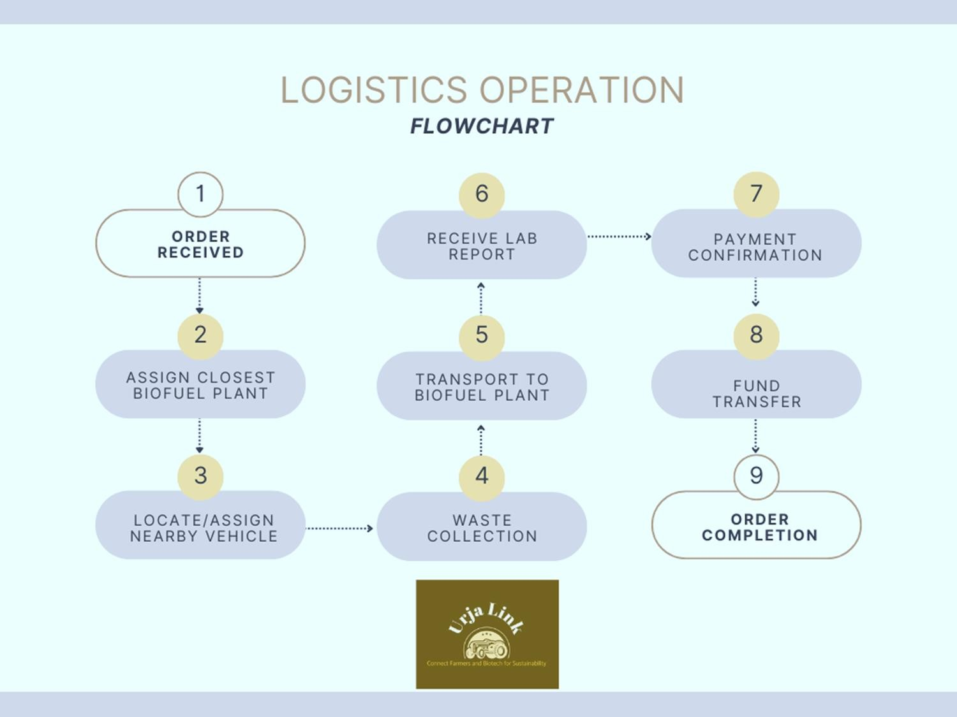Route optimization identifies the best route available for transport.

## Quality Assessment & Payment Processing

* + Once delivered, biofuel companies test stubble quality and assign a grade.
  + Based on the quality reports, we finalize pricing and inform the farmer.

Secure payment processing ensures timely transfers to farmers post-verification.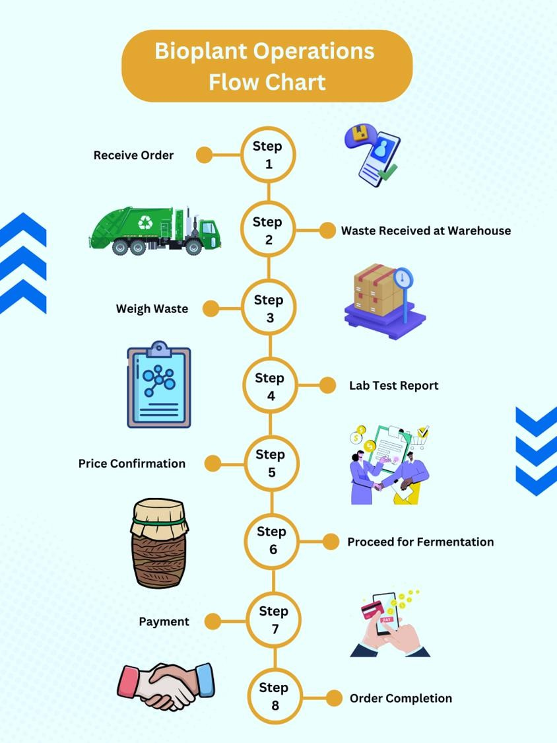

## 2. Net-Positivity Impact

URJA LINK promotes economic, environmental, and social benefits through sustainable stubble management.

### Environmental Benefits

✔ Reduces Air Pollution: Prevents harmful emissions from stubble burning.

✔ Enhances Soil Health: Prevents nutrient loss caused by burning residues.

✔ Promotes Renewable Energy: Converts agricultural waste into sustainable biofuel.

### Economic Benefits

✔ Generates Additional Income for Farmers: Farmers profit from stubble instead of wasting it.

✔ Reduces Biofuel Production Costs: Ensures a steady, cost-effective biomass supply.

✔ Optimized Logistics Reduces Costs: AI-based transport matching minimizes inefficiencies.

### Social Benefits

✔ Creates Rural Employment: More jobs in logistics, collection, and testing.

✔ Empowers Farmers: Transparent pricing and guaranteed payments improve financial stability and confidence.

Thus, URJA LINK’s AI-powered logistics framework matching helps our company to create an efficient, sustainable, and profitable ecosystem for farmers and biofuel companies. By eliminating waste and optimizing transportation, URJA LINK drives a net-positive impact on the environment, economy, and rural communities.

## Ease of Access to the Website:

Farmers prefer a user-friendly interface with regional language support. Given that many may have limited experience with smartphones, incorporating voice commands is crucial and will be a key focus during the initial testing phase. To enhance accessibility, we have integrated an AI assistant that allows farmers to interact seamlessly. If the AI assistant does not fully address their queries, they are directed to a customer executive for a live conversation. This ensures that even farmers without smartphones can register their products efficiently. The website enables ease of booking by simple step-by-step process to schedule waste collection. Integrating AI to determine the locations of farmers and biofuel companies enables logistics optimization by identifying the most efficient routes, reducing transportation costs, and minimizing delays in stubble collection and delivery.

## Training the AI:

At this MVP stage, we have integrated AI-assisted customer call features and geographic location tracking. The website has been trained with market data on various agricultural wastes, enabling automatic price calculations based on the buyer’s required quantity. Additionally, we have included an image upload feature for stubble, with plans to implement AI-powered image analysis in the future. This enhancement will allow the system to assess quality estimates early on, aiding in better segregation. Furthermore, AI will use historical market images to learn and classify waste quality, enabling it to analyze and verify the quality of uploaded samples from farmers.

## Target for future AI training:

1. AI in Route Optimization:
   * When a user selects multiple farms, AI will automatically generate the most efficient collection route, minimizing distance, reducing fuel costs, and ensuring timely pickups.
2. AI in Customer Support:
   * Conversational AI (Chat & Voice): Enhances customer interactions through AI-driven chatbots and voice assistants.
   * Customer Inquiry & Response Data: AI learns from past chat logs, call transcripts, and email exchanges to improve responses.
   * Named Entity Recognition (NER) Training: Helps AI identify key details such as items, locations, quantities, and dates in conversations.
   * User Profiles & Interaction History: Personalizes AI responses based on previous interactions with the user.
3. AI-Driven Market & Environmental Insights:
   * Weather & Seasonal Data: AI considers seasonal variations in agricultural waste availability.
   * Market Pricing Data: AI suggests dynamic pricing for stubble based on market demand.
   * Regulatory Compliance Data: Ensures waste management regulations are followed before listings are approved.
4. Future Expansion Plans:
   * Product/Waste Category Expansion: AI will support additional waste types such as sawdust and used cooking oil.
   * Measurement Standardization: AI will recognize and process standard units (kg, liters, tons) to ensure accurate data interpretation.
   * Timestamp Data Utilization: AI will automatically record waste production dates, helping users track and manage their inventory efficiently

## Iterative Improvements from Phase 1 to Final Version Financial Projection Summary

**Market Target:**

* + **TAM:** 352 million tons (stubble waste in Uttar Pradesh)
  + **SAM:** 15 million tons
  + **SOM:** 750,000 tons (5% of SAM)

**Revenue Target:**

* + **1st Year Goal:** Acquire **1,000 farmers**, process **750,000 tons** of stubble waste at **₹5,900/ton**, generating **₹663.75 million** in revenue with a **15% margin per transaction**.

**Cost strategy:**

**Year 1:**

* The company will rely on outsourced logistics services, incurring a cost of **₹900 million** to support initial operations.

**Year 2 and 4:**

* To optimize costs, the company will invest in **10 electric vehicles** for in-house logistics management, gradually reducing dependence on third-party logistics providers.
* Expansion efforts will be implemented alongside the logistics transition to enhance operational efficiency.

**Cost Optimization:**

* **Gradual Reduction** in marketing and website management expenses to improve cost efficiency.
* **Government Subsidy Utilization** to offset operational costs and enhance financial sustainability.

## 

## Version 1: (Current version)

* + Tested accessibility and stability of the webpage to ensure seamless user experience.
  + Integrated three initial waste categories for buyers, based on India's most common crops. Changed one of the crop waste category from Sugarcane to Corn waste, given the burning of sugarcane crop for easy harvest and transport.
  + Added a customer support call button to assist users with issue resolution.
  + AI Training Implementation: As outlined in the "T**raining the AI**" section, we have integrated AI-assisted customer call features, geographic location tracking and price calculation.
  + Payment Method & Tracking System: Buyers finalize costs after quality testing and receive automated invoices. Multiple payment options (bank transfers, cash, etc.) will be integrated for flexibility.

## Version 2: (in Future)

We aim to train the website to integrate the following key features:

* + User Profiles and Tracking: Farmers will be able to track CO₂ reductions and total sales, while biofuel companies can monitor waste-to-fuel conversion rates. These profiles will remain private but may later be linked to a rating system for credibility and trust-building.
  + Notification System for Transparency: A real-time notification system will provide alerts for completed transactions, shipment updates, and payment statuses. This feature enhances transparency and enables farmers to build their ratings for future transactions.
  + Payment Tracking System: A visual payment tracking system will be integrated to streamline the invoice process, ensuring users have clear visibility into their payment statuses and transaction histories.
  + Minimum Transaction Limits for Efficiency: To ensure smooth transactions, minimum purchase and sale limits will be set. This helps reduce waste for farmers while optimizing logistics costs, making the process more efficient for all stakeholders.
  + Dynamic Counteroffer System: A flexible counteroffer system will allow biofuel companies to specify the type and quantity of waste they want to purchase. Farmers can highlight the quality of their stubble (e.g., organic) and negotiate for better pricing, improving supply-demand alignment.
  + User Feedback Integration for Continuous Improvement: A structured user feedback mechanism will be implemented to gather insights from farmers and biofuel companies. This data will be used to identify pain points, refine platform features, enhance transaction processes, and optimize logistics for improved overall efficiency.

## Version 3

* + Expansion to Food Waste & Paper Companies: Broadens market scope and enhances waste utilization. This expansion strengthens sustainability efforts and increases the platform’s impact on the circular economy. This also helps us to maintain our operations throughout the year.
  + Global Footprint: We intend to expand to other markets like Indonesia, Philippines, Mexico and Brazil where crop burning is still prevalent.
  + Demand Projection & Logistics Optimization: Demand projection using AI helps us balance supply and demand, reducing waste and costs. Seasonal demand fluctuations require flexible fleet management, and partnerships with local transport providers may be more cost-effective than owning a fleet. Government incentives and carbon credit programs will also be explored for long-term viability.
  + Biofuel Facility Coordination: Data analytics will be used to forecast supply collection volumes. Collaboration with multiple biofuel plants will help manage supply-demand fluctuations and ensure a stable supply chain.

URJA LINK’s AI-powered logistics platform effectively bridges the gap between farmers and biofuel companies, creating a sustainable and profitable supply chain for agricultural waste. By integrating AI- driven logistics, real-time tracking, and secure payments, the platform enhances efficiency, reduces waste, and supports environmental and economic sustainability. Future enhancements, including dynamic pricing, demand forecasting, and expansion to new waste categories, will further optimize resource utilization and strengthen the biofuel industry. URJA LINK’s scalable model ensures long- term impact, benefiting farmers, businesses, and the environment alike. As solution development is an iterative process, we will continue refining and improving our product until an optimal and scalable solution is achieved.

# References

Buyofuel. (n.d.). *Bagasse price in India: Market forces*. [https://buyofuel.com/blogs/bagasse-price-india-](https://buyofuel.com/blogs/bagasse-price-india-market-forces/) [market-forces/](https://buyofuel.com/blogs/bagasse-price-india-market-forces/)

Narsi. (2024, December 3). *Rice straw in India - Availability, supply chain, prices, surplus - BioBiz*. BioBiz. <https://biobiz.in/s/bring/in/12>

Profodd Private Limited. (n.d.). *Wheat straw hay*[.https://www.profodd.com/wheat-straw-hay.html](https://www.profodd.com/wheat-straw-hay.html)

International Energy Agency. (2023, October 4). *India could triple its biofuel use and accelerate global deployment*. IEA. [https://www.iea.org/commentaries/india-could-triple-its-biofuel-use-and-](https://www.iea.org/commentaries/india-could-triple-its-biofuel-use-and-accelerate-global-deployment) [accelerate-global-deployment](https://www.iea.org/commentaries/india-could-triple-its-biofuel-use-and-accelerate-global-deployment)

Press Information Bureau, Government of India. (2018, August 10). *Government approves National Policy on Biofuels – 2018*. PIB. <https://pib.gov.in/newsite/printrelease.aspx?relid=183388>

Press Information Bureau, Government of India. (2015, April 15). *Government promoting production of organic fertilizers*. PIB. <https://pib.gov.in/newsite/PrintRelease.aspx?relid=124299>

ScienceDirect. (2024). *Assessment of India's biofuel production potential and policy framework*. ScienceDirect. <https://www.sciencedirect.com/science/article/pii/S240584402415846X>

National Center for Biotechnology Information. (2019). Impacts of crop residue burning on air quality and human health. National Library of Medicine. https://pmc.ncbi.nlm.nih.gov/articles/PMC6427124/

Food and Agriculture Organization. (2021). Crop residue management for sustainable agriculture and climate resilience. FAO Open Knowledge Repository. https://openknowledge.fao.org/server/api/core/bitstreams/a89a226c-d9e7-48f6-a90f-ac8759c533d7/content

Department of Agriculture & Farmers Welfare, Government of India. (2024). Land use statistics 2022-23. https://desagri.gov.in/wp-content/uploads/2024/09/Final-file-of-LUS-2022-23-for-uploading.pdf

Contd..

# BROCHURE:

